**(Lecture 10)**

**HTML Layout Structure**

**Floats**

An element can be floated to the right or to left by using the property float.

It is a css property

It is using in block tags.

**Example :**

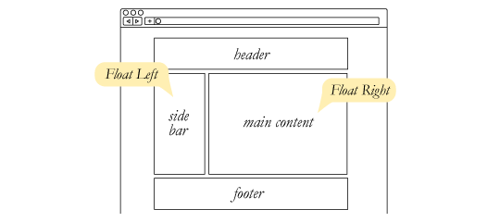

**The basic layout structure.**

There are three basic structures of layout

1. one column

2. two column

3. three column

**One column :**

**Code :** <div style="text-align: center">

<div>header</div>

<div>mid</div>

<div>footer</div>

</div>

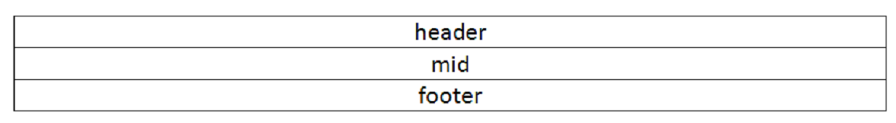

**(Lecture 10 - I)**

**Two Column**

**Code :** <div style="text-align: center; width:500px;">

<div>header</div>

<div>

<div style="width:200px; float:left">left</div>

<div style=" width:290px; float:right;">right</div>

</div>

<div style="clear:both;">footer</div>

</div>

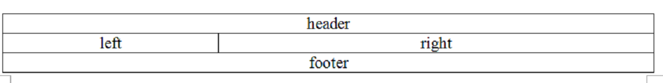

**Three Column**

**Code :**  <div style="text-align: center; width:500px;">

<div>header</div>

<div>

<div style="width:100px; float:left">left</div>

<div style=" width:280px; float:left; margin:0px 10px;">mid</div>

<div style=" width:100px; float:left;">right</div>

</div>

<div style="clear:both;">footer</div>

</div>

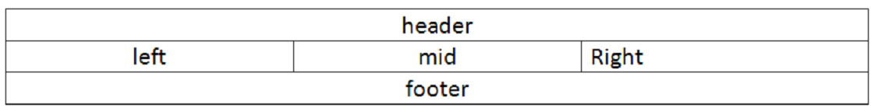

**(Lecture 10 - II)**

**Assignment:**

Create 3 The basic layout structure

Create that image layout structure by using that calculation too

